- How many high pressure systems (Highs) are shown on the weather map? Where are their centers located? In your answer, use either state names or geographic regions of the country (e.g., Mid-Atlantic states) to describe the location of the Highs.

- How many low pressure systems (Lows) are described on the weather map? Where are their centers located?

- What kinds of fronts are shown on the weather map? Where are they located?

- Where is the weather likely to be fair (clear and dry)?

- Where is it likely to be stormy (cloudy, with a chance of precipitation)?

- According to the weather map, what is the weather likely to be in your area? Is it?

- Based upon the current surface weather map, forecast (predict) tomorrow's weather for your location.

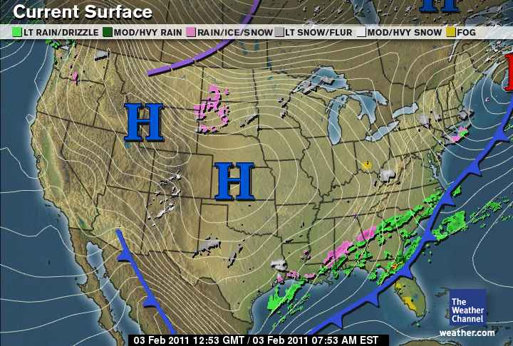

Ocean Currents
• An ocean current is the flow of water around the ocean. The direction and strength of currents are influenced by ocean contours, shoreline configurations and interaction with other currents. Surface currents can be affected by wind, solar heating, gravity and tides. Deep water currents, which account for most of the water on Earth, are much colder and can be affected by salinity.

Water Density
• Air can vary greatly in temperature within a single day or even seasonally. However, since water is so much denser than air and takes so long to change temperature, it can have much more of a moderating effect on the land around it, counteracting the large variations typically present.

Warm and Cold Weather Currents
• As currents carry warm water into colder regions, the heat from the water enters the atmosphere and creates warmer, rainier weather. These are called warm ocean currents, but there are also cold ocean currents which allow colder water to flow into warmer regions and decrease the chance of rainfall. The Gulf Stream is one of the more well-known ocean currents. It brings water from the Gulf of Mexico up along the eastern coast of the United States and all the way into the North Atlantic. This brings milder and rainier weather to Britain than its latitude would normally suggest.

Inland Temperatures
• Temperatures along the coast can be different than temperatures several miles inland. In many places, it is cooler during the day but warmer during the night. Since only regions near the ocean will experience the windfall from currents, you are less likely to experience the effect the farther inland that you travel.

El Nino and La Nina
• El Nino is the attenuation of major trade winds in the central and western Pacific during Christmas, allowing warm water to enter the eastern Pacific and increase surface pressures. Fisheries may be disrupted when the nutrient-rich northward cool currents are displaced. La Nina has a cooling effect and lowers surface pressure.

